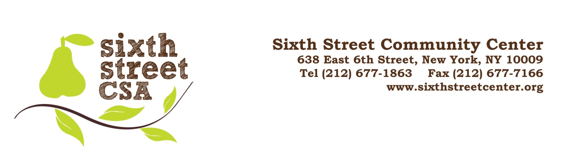CSA MEMBERSHIP REGISTRATION AGREEMENT
SUMMER – FALL 2019

Name(s) _____________________________________________________________________________

Address _____________________________________________________________________________

______________________________________________________ Zip ________________________

Telephone (day) _____________________________ (eve) ___________________________________

Email 1______________________________________ Email 2_________________________________

Please check one or more options below. A minimum of $150 is required to join.

● VEGETABLE SHARE (Hepworth Farm, NY) 24 Pick-ups: June 11 – Nov. 19, 2019
FULL SHARE (avg. 14 lbs/wk)  □ Income above $80,000 $830  □ Income $50,000 - $80,000 $785  □ Income $30,000 - $50,000 $740  □ Income below $30,000 $500* | HALF SHARE (avg. 8 lbs/wk)  □ Income above $80,000 $550  □ Income $50,000 - $80,000 $505  □ Income $30,000 - $50,000 $480  □ Income below $30,000 $340*
*Limited number of shares for individuals and families receiving SNAP benefits. Please provide a copy of your EBT card along with the membership registration form.

□ FRUIT SHARE (Hepworth Farm, NY) 23 Pick-ups: June 18 – Nov. 19, 2019

_____ Season Share $365 (avg. 5 lbs/wk)

Make a donation to support additional low-income memberships!
All donations are tax-deductible
Please check with your HR Department to see if your company will match your donation
___ $10 ___$20 ___$50 ___$100 Other $______

Total Amount Enclosed $ ___________
Return this form to the address above with your payment. Make your check or money order payable to Sixth Street Community Center CSA.

PLEASE READ AND FILL OUT MANDATORY AGREEMENT ON REVERSE SIDE

I/We _________________________ understand the benefits and risks of the growing season are shared by all and agree to the responsibilities of membership in Sixth Street Community Center CSA:

Payments – Payment is due at your first pick up. Installment plans are available if needed. Late registrations are accepted, your payment will be pro-rated from the date of your first pick up. Call 212-677-1863 to arrange. (Please note that there are no refunds).

Committee Involvement -- Members are required to participate in at least one of the committees below (please check one). Note that for Site Management you will be emailed a link to Sign Up where you can sign up for your shifts. The other committees will meet to arrange their schedules and tasks.

CSA Committees:
- Site Management Committee - Set up and distribute produce (4pm-6pm), handle inquiries and other needs (6pm-8pm) or breakdown and clean-up (8pm- 10pm). At least two shifts required during the season. Take this opportunity to get to know your fellow members and neighbors.
- Newsletter & Social Media Committee – Members prepare the weekly newsletter (write articles, select recipes or publicize community and current events), design event flyers or assist with social media.
- Café Committee – Help with prep work for dinners served at Organic Soul Café.
- Events & SOS Food Advocacy Committee - Members organize farm trips, potlucks, film screenings, food justice and other events. Collaborate with Just Food, Lower East Side Girls Club and other not-for-profit groups.

Produce Pick-ups and Absence -- Pick-ups are Tuesdays 5pm – 9pm at Sixth Street Community Center. If you are unable to pick up your share during these hours, please call and your share will be set aside for pick-up on another day. (Please use this option sparingly). If you do not call your share will be given away to an emergency food program or soup kitchen. If you plan to be away for an extended period of time let us know if someone will be picking up in your place. Finally, please notify us if you decide to terminate your membership.

Bags - Members are encouraged to bring their own bags for pick-ups as to reduce our use of plastic. We normally do not have bags available.

Signature Date __________________

